Quantum Computing: Fact or Fiction
Yu-Chin Chiang
Department of Computer Science University of Warwick

Abstract—Quantum computing is one of the most disruptive and transformative computing paradigms since the invention of the transistor. This powerful computing capability stems from the application of the principles of quantum mechanics. In particular, superposition, entanglement and interference. For processing information in ways that the classical computers cannot. But de- spite significant theoretical advance and experimental progress, it remains unclear if fault-tolerant quantum computing will ever be possible. This paper outlined a theory of quantum computing and
B. Entanglement and Bell States
As is well known, entanglement is the essential resource in quantum computing that separates it from classical proba- bilistic computing. When two qubits are entangled, we have that the state of the system cannot be written as a product of individual states. The following two Bell states are said to be maximally entangled:

emphasised the engineering problems that must be surmounted to achieve it, contrasting pessimistic and optimistic viewpoints. Last, future research directions are presented in fault-tolerant
+
|Φ ⟩ = 1/√2(|00⟩ + |11⟩). (2)

structures, quantum error correction and classical computation in hybrid quantum computing, among others.
Index Terms—Quantum computing, quantum mechanics, quantum error correction, superposition, entanglement, and computational complexity.
I. Introduction
Quantum computation is a model of computing that uses quantum phenomena to store and process data. Unlike classical bits, which must take the value of 0 or 1, quantum bits
This non-local correlation is central to protocols like quan- tum teleportation and superdense coding, but incredibly fragile with respect to environmental noise.
C. Quantum Gates
Computation is performed by unitary matrices. For example, the Hadamard gate (H) enables superposition to be generated:
1 1 1

(qubits) can exist in a superposition of states, meaning that
H = √2
1 −1
. (3)

an exponential number of computations can be carried out simultaneously [1]. Quantum computing is founded on linear algebra, and the unitary operations correspond to reversible evolution of quantum states.
Quantum computation was first conceptually suggested by Feynman and Deutsch [2], [3], that is, some physical systems can be simulated much more efficiently on quantum computers than on standard ones. Later algorithms, for example Shor’s factoring [4] and Grover’s search [5], showed clear quantum speedups on specific problems. But even approximating this ideal performance in practice can be very difficult.
- Theoretical Foundations
To appreciate the difference between fiction and reality, one must understand the mathematics that underlies quantum mechanics.
A. Qubits and The Bloch Sphere
A classical bit is either 0 or 1. A quantum bit, or qubit, on the other hand can be represented by a state vector ψ in 2-dimensional complex Hilbert space:
| ⟩

|ψ⟩ = α|0⟩ + β|1⟩, (1)
where and are probability amplitudes and satisfy the nor- malization constraint. Unlike classical bits, a qubit can be in any superposition of states between 0 and 1; the state of a pair of qubits is described by an entangled state.
In reality, the realisation of such gates in perfect fidelity represents a big engineering challenge.
- The Mathematics of Shor’s Algorithm: A Case Study
To fully appreciate the “Fact” of quantum speedup, Shor’s Algorithm must be understood. This algorithm is not an illusion, but a beauty dance of classical number theory and quantum period finding.
  - The Factoring Problem
In the classical world finding the prime factors of a com- posite N is hard. The best known classical algorithm is the Number Field Sieve (NFS) which has a super-polynomial complexity written as:
O exp c(log N )^{1/3}(log log N )^{2/3} (4)
Shor’s algorithm, on the other hand, exactly solves this prob- lem in polynomial time, or more specifically O((log N )³).
  - Quantum Period Finding
The central quantum transformation is evaluating the period
r of function f (x) = a^{x} mod N .
Superposition: We start with a register of qubits initialised in a superposition over all integers x.

y
|0⟩
|ψ⟩
x

|1⟩

Fig. 1. The Bloch Sphere representation. Unlike a classical bit, a qubit state |ψ⟩ can exist anywhere on the surface. [1]

Superposition
H
+
|0⟩

|0⟩
Entanglement

Fig. 2. A basic quantum circuit illustrating the generation of a Bell State using a Hadamard gate and a CNOT gate. [1]

Modular Exponentiation: Using quantum parallelism, we calculate for all x, their modular exponentiation equation a^{x} mod N .
Quantum Fourier Transform (QFT): This is the non-trivial part and imply interference. We apply the QFT to the input register, constructive interference will amplify those values that are multiples of r:
M−1
Σ
B. Trapped Ions
Worked upon by IonQ and Honeywell, trapped ions are confined using electric-magnetic fields. Except the coherence time and the gate fidelity, they offer superior performance in both compared to superconducting qubits. Their gate velocities are, however, quite low and scaling the number of ions in a single trap is extremely challenging.

1
QFT|x⟩ = √
M
y=0
e2πixy/M
|y⟩ (5)
C. Photonic Qubits
There are companies, such as PsiQuantum, that utilize the nature of photons. This method has the advantage of working

Measurement: Measurement gives us a value, which allows the determination of r via continued fraction expansion. If r is found, factors N can be found with gcd(a^{r/2} 1, N ).
±
This mathematical guarantee is the coolest “Fact” about quantum computing. Yet, the hardware embodiment of the Modular Exponentiation circuit when N is large would require millions of gates again bringing us back to noise ”Fiction”.
- Physical Implementations: The Hardware Race
Qubits on paper work great; qubits in the lab, less so. There are many competing technologies that seek to dominate, and each has its own strengths and weaknesses.
  - Superconducting Circuits
These circuits, championed by the likes of Google and IBM, operate like artificial atoms. They work with fast gate times (of the order of nanoseconds) but are limited by short coherence times and require large dilution refrigerators to cool down down to temperatures near absolute zero (10 − 20 mK).
at room temperature and the simplicity for implementation with standard telecommunication facilities. On the other hand, photon-photon interactions are weak and two-qubit gates are probabilistic and complicated.
D. Neutral Atoms
While superconducting circuits and ions are presently the most advanced architectures, atomic arrays have recently been put forward as a promising platform for scalable quantum computation. This is a technology being developed by compa- nies like QuEra and Pasqal, among others that uses tightly focused optical tweezers to hold individual atoms—usually Rubidium or Strontium—inside a vacuum chamber.
The biggest advantage of the technology is its phenomenal connectivity. These atoms can interact with neighboring ones over substantial ranges by exciting them to high energy Rydberg states, such a coupling is based on what is called the ohmic, all-round interaction [7]. While superconducting chips are confined to a fixed 2D grid fabrication, atom arrays

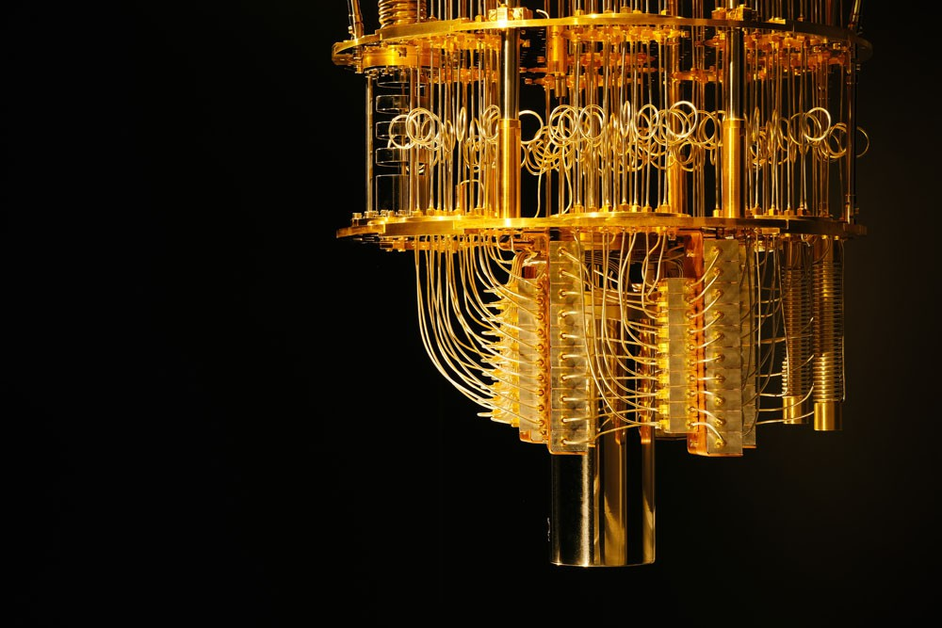

Fig. 3. The ”Chandelier” structure of a superconducting quantum computer. The complexity of wiring illustrates the scalability challenge. Image source: IBM Research [6].

can experience real-time rearrangement into arbitrary 2D and even 3D geometries. This flexibility allows native support for complex graph problems that would otherwise incur significant overhead in swapping operations on other platforms.
On the other hand, their main disadvantage is that there is an illusion that they are ready for large-scale use. Neutral atoms are also quite difficult to control, the atom loss in a trap being not negligible, and gate fidelities (while increasing) lag behind those for trapped ions. In addition, the frequency of operations is relatively low comparing with superconductors. However, the ability to densely integrate thousands of identical qubits in a compact vacuum chamber without complex wiring makes it one to watch.
- Related Work
Quantum computing went from a topic mainly of theoretical interest to one we started to experiment with in practice. Most studies have concentrated on the quantum information theo- retic formalism [1], but in recent years attention has shifted toward scalable realizations with superconducting circuits, trapped ions and photonic devices.
Google’s 2019 claim of quantum supremacy [8] was a landmark result because it demonstrated that a 53-qubit super- conducting processor could solve a sampling problem that the best classical supercomputer couldn’t. IBM argued, however, that the corresponding task could be classically simulated in a reasonable time [9].So, this is another entry in the conversation about the theoretical-empirical divide.
Error correction, however, continues to be a controversial topic. Even surface codes and topological qubits do not scale up to realistic devices, since thousands of physical qubits are needed for a single logical qubit, which makes scaling rather hard. Hybrid quantum-classical algorithms (such as the Variational Quantum Eigensolver or Quantum Approximate
Optimization Algorithm) and noisy intermediate scale quan- tum technology provide other research directions.
- Critical Analysis
One of the defining features of quantum computing is its formalistic orientation, where a theory has been developed as a branch of set theory — largely in and for itself. Yet, going from theories to real devices we disclose with many physical limitations beyond technical inconveniences that are intrinsic due the thermodynamic laws.
- The Reality of Decoherence
In the quantum mechanical world it is accepted as a fact that environmental factors can disturb a quantum system. So-called decoherence times – timelines for which qubit information is no longer well defined [10] – can arise from even tiny inter- system interactions, such as thermal fluctuations or electro- magnetic background radiation. While coherencetimes (T₂) have increased orders of magnitude—from the nanosecond range when experiments were first performed, to several hundreds of microseconds in today’s superconducting cir- cuits—operations have become exponentially more complex. A successful quantum algorithm needs to finish calculations far before the coherence time. Presently we have a very low “depth” of the circuits that have been run. Other researchers argue that decoherence puts a limit on scalability that cannot be fully compenssated for, relegating quantum computers to certain applications featuring shallow circuits.
- The Overhead of Quantum Error Correction
The Quantum Error Correction (QEC) is the proposed de- vice to fight against decoherence, but with considerable losses. While classical bits can be copied to provide redundancy (as in repetition codes), quantum states cannot, because of the no-cloning theorem. Instead, we have to work with syndrome

TABLE I
Comparison of Leading Qubit Technologies

Tech | Pros | Cons
Superconducting | Fast gates, lithographic scalability | Low coherence time, requires cryogenic cooling
Trapped Ions | High fidelity, extended coherence | Slower operation, difficult to scale trap size
Photonic | Room temperature, telecom native | Probabilistic gates, photon loss
Silicon Spin | High pump density, standard CMOS Technology | Fabrication variations and limited range coupling

measurements, e.g., the Surface Code. The threshold theorem tells us that fault tolerance is possible if the physical error rate is smaller than about 10⁻³ per gate [11]. However, the overhead of QEC is huge. By current estimates, in order to realize a single logical fault-tolerant qubit that can store data forever, we need somewhere between 1,000 and 10,000 physical qubits.
~
The high overhead in quantum error correction comes from the nature of the correction procedure and to see why this is we have to look at how one runs a quantum error correcting code. In conventional error-correcting coding (ECC) systems, errors may be detected through a direct observation of data bits. Yet, in quantum mechanics this is not possible – observing a data qubit breaks its superposition and thus violates the very computation we want to protect.
This limitation leads to the engineering notion of ”Syn- drome Measurement”. We cannot see the data, what we can observe are only error estimates. This is done by encoding the data qubits into a code formed from auxiliary ”ancilla” qubits, over several rounds of the mathematical operation search = 0;1 at a time. If we measure the ancillae, we can obtain the “parity” (also called syndrome that will give information about whether there are errors in data qubits) of our data qubits without any knowledge on their exact states. For the operation of a Surface Code, this cycle between entanglement, measurement and reset must be performed at regular intervals faster than the decoherence time.
So nearly all of the qubits do not “compute” in a fault- tolerant quantum computer. Instead they are ”plumbers”, for- ever checking for leaks in the quantum information. This enormous housekeeping overhead is one of the reasons that only a few hundred useful logical qubits may be derived from a million-qubit processor.
This means that for Shor’s algorithm, to factor RSA-2048 (which requires roughly 4,000 logical qubits), we would need a machine with millions of physical qubits. Considering that the most sophisticated computers today have a few hundred qubits, the “reality” to “science fiction” discrepancy is about four orders of magnitude.
- Scalability and The Interconnect Bottleneck
Another main challenge is the scalability, which goes be- yond just the number of qubits. At the experimental level, leading contenders are superconducting and ion-trap tech- nologies but encounter the “interconnect bottleneck.” For superconducting chips, every qubit requires its own control lines (coaxial cables) that need to be brought from room temperature down to the millikelvin stage. A processor with
1,000 qubits, meanwhile, would require thousands of cables and generate heat that exceeds the cooling capacity of the dilution refrigerator. This situation is diametrically in contrast with classical industrial chips, which may count billions of transistors but will occupy only hundreds of I/Os. Unless cryogenic control electronics, controlling qubits within the refrigerator are practical, scaling to millions of qubits needed for QEC will be a major engineering challenge.
- Algorithmic Reality: Fact vs. Fiction
The phrase “quantum supremacy” implies that quantum computers are superior for all computational tasks. This as- sertion is an oversimplification.
- Algorithmic and Complexity Considerations
Even with perfect hardware, quantum algorithms are not categorically faster than their classical counterparts. Virtually all quantum algorithms known to date offer only polynomial, not exponential, speedups [1]. Furthermore, classical com- puting is still advancing: advances in GPU-based parallelism and approximation heuristics—and recently, breakthroughs with quantum-inspired algorithms—have reduced the speedup gap for many applications. As a consequence, the story of “quantum advantage” starts to sound somewhat overblown. An alternate view is that quantum computing could have domain-specific advantages if not approach a general-purpose computational revolution.
- Exponential vs. Polynomial Speedup
Shor’s algorithm allows for an exponential speedup in the factorization problem, and is a major threat to RSA. Grover’s algorithm, on the other hand, receives merely a quadratic speedup (from O(N) to O( N )). This discrepancy is a sig- nificant one, but it may be mitigated in practice by the slow clock cycle times of quantum gate operations for some time to come.
√
- The NISQ Solution: Variational Algorithms
Since quantum hardware which can run the error corrected version of Shor’s algorithm is still many decades off, industry has moved toward a more pragmatic middle solution - NISQ (Noisy-Intermediate-Scale Quantum) algorithms. The most well-known of these is VQE [81].
VQE embodies a ”Hybrid” approach: it acknowledges that quantum computers are bad at performing long and difficult calculations, but they’re good at representing complex wave- functions. In VQE, the quantum processor is used purely as a co-processor to prepare an estimate of a quantum state

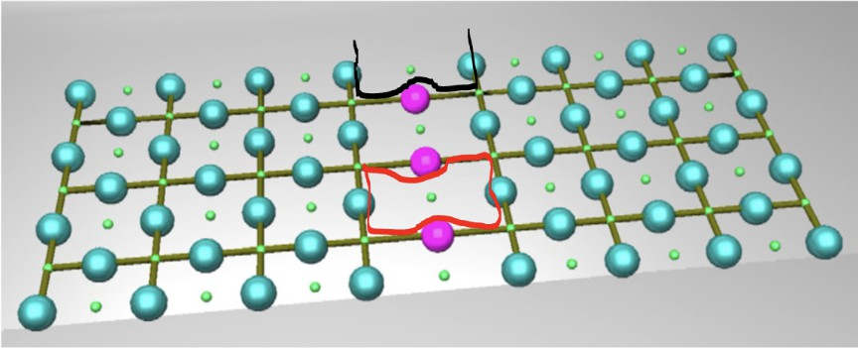

Fig. 4. Visualizing the QEC overhead. A vast number of noisy physical qubits (red grid) is necessary to keep a single logical qubit stable (blue). This inconsistency (by a factor of 1000) is the biggest challenge to scaling up. Diagram adapted from [11].

and measure its energy. A classical computer then uses this output in a classical optimization loop (gradient descent, for example) to update the parameters of the quantum circuit toward discovering the state with minimum energy (or ground state).
This approach, which carries the promise to be useful in quantum chemistry and materials science (such as simulating the molecular structure of lithium hydride or designing novel battery materials [12]), is motivated by neural networks. The ”fact” is that VQE has a resilience against specific types of noise since systematic errors can be corrected for by the classical loop. But the ”Fiction” is that we know there’s a way out, which brings us back to The PR quest for proving VQE leads to computational advantage; it faces its own mathematical barriers, such as Barren Plateaus where your classical optimizer gets itself islanded in a flat landscape when looking for a solution.
- The Data Loading Problem
A critical and often neglected barrier is the ease of data entry. Classically loading big data into quantum superposition (also known as Quantum Random Access Memory, QRAM) is expensive and can take longer than the problem depth. This suggests that quantum computing is likely to be used as a special co-processor for certain algorithmic tasks, such as chemical simulation problems, rather than an all-purpose big data computer.
- Suggested Future Work
In the future, more theoretical research should be connected to its application in practice. Three major directions stand out:
- Fault-Tolerant Architectures
The aim is to develop fault-tolerant systems. Research on topological qubits and bosonic codes holds the promise of fault tolerance inherent to encoding crosstalk and global quantum properties [13]. Advancements in materials science and cryogenics might further enhance the stability of qubits.
- Hybrid Quantum: Classical Models
Due to the constraints of Noisy Intermediate-Scale Quantum (NISQ) devices, hybrid computing models that assign some amount of job load to quantum and classical systems are very appealing [10]. Already, algorithms such as VQE and QAOA have been demonstrated to be promising in chemistry problems and tasks involving optimisation.
- Quantum Simulation and Verification
Quantum simulation is one of the most promising appli- cations in the near future. Modelling of quantum phenomena is directly possible with systems such as ultracold atoms and trapped ions, which accelerates the progress in materials sci- ence, informed crosstalk, and global physics [14]. Moreover, the verification protocols are as important to verify that we have true quantum advantage.
- Conclusion
Quantum computing is a melding of revolutionary theory and daunting engineering, as at the frontier of any field. The theory of quantum speedups is solid, but their experimental realisation has proven elusive. The present NISQ age, with its set of experimental platforms, is not universal. Further refine- ments in error correction, architecture, and hybrid computing will determine if quantum is a near-term reality or a long-term dream.
References
- M. A. Nielsen and I. L. Chuang, Quantum Computation and Quantum Information. Cambridge University Press, 2010.
- R. P. Feynman, “Simulating physics with computers,” International Journal of Theoretical Physics, vol. 21, no. 6, pp. 467–488, 1982.
- D. Deutsch, “Quantum theory, the church–turing principle and the universal quantum computer,” Proceedings of the Royal Society A, vol. 400, no. 1818, pp. 97–117, 1985.
- P. W. Shor, “Algorithms for quantum computation: Discrete logarithms and factoring,” Proceedings of the 35th Annual Symposium on Founda- tions of Computer Science, pp. 124–134, 1994.
- L. K. Grover, “A fast quantum mechanical algorithm for database search,” Proceedings of the 28th Annual ACM Symposium on Theory of Computing, pp. 212–219, 1996.

- IBM Research, “Ibm quantum computing press kit,” 2024, accessed: 2024-11-27. [Online]. Avail- able: https://newsroom.ibm.com/media-quantum-innovation?keywords= quantum&l=100#gallerygallery0:21747
- M. Saffman, T. G. Walker, and K. Molmer, “Quantum information with rydberg atoms,” Reviews of Modern Physics, vol. 82, no. 3, p. 2313, 2010.
- F. Arute et al., “Quantum supremacy using a programmable supercon- ducting processor,” Nature, vol. 574, no. 7779, pp. 505–510, 2019.
- E. Pednault, J. A. Gunnels, G. Nannicini, and J. M. Gambetta, “On “quantum supremacy”,” IBM Research Blog, 2019.
- J. Preskill, “Quantum computing in the nisq era and beyond,” Quantum, vol. 2, p. 79, 2018.
- A. G. Fowler, M. Mariantoni, J. M. Martinis, and A. N. Cleland, “Surface codes: Towards practical large-scale quantum computation,” Physical Review A, vol. 86, no. 3, p. 032324, 2012.
- A. Peruzzo, J. McClean, P. Shadbolt, M.-H. Yung, A. Aspuru-Guzik et al., “A variational eigenvalue solver on a photonic quantum processor,” Nature Communications, vol. 5, p. 4213, 2014.
- B. M. Terhal, “Towards scalable fault-tolerant quantum computing,”
Nature Reviews Physics, vol. 2, pp. 347–360, 2020.
- I. M. Georgescu, S. Ashhab, and F. Nori, “Quantum simulation,” Reviews of Modern Physics, vol. 86, no. 1, pp. 153–185, 2014.

